3-15
In this one the inlaw roof is exactly lined up with the main roof.
But no tie in trouble because the flat roof makes the break.
Also no trouble with water at the side of the garage and the valley is steeper therefore safer.

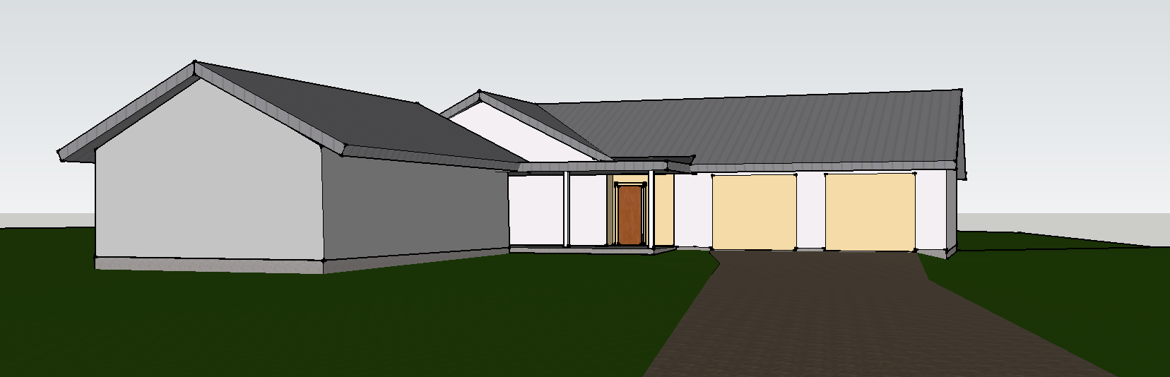

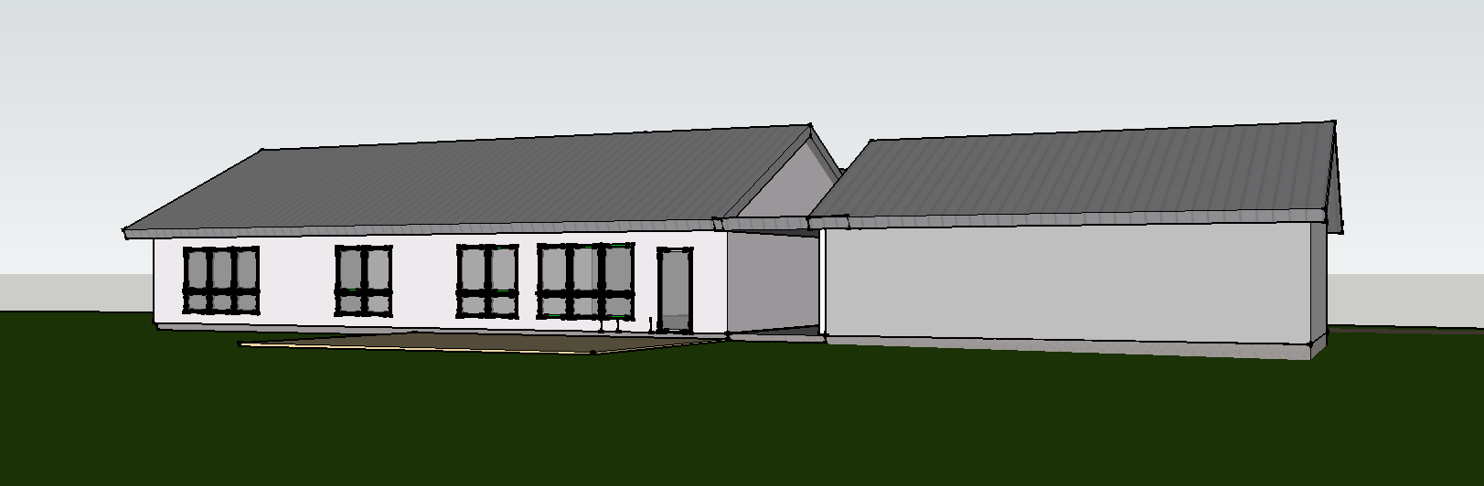
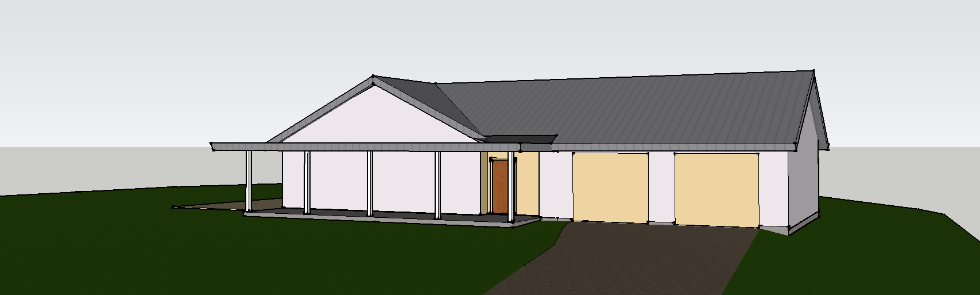

3-14
Pluses
All pitches are above 4/12
The end of the valley is back 3.5' from the driveway
Just one valley to build
Minuses
It would take a lot of screen to screen in the porch and more framing than I am showing so far. Current posts are about about 8' apart.
Still a low slope valley on the north side
There will be some water overflow in that corner no matter what we do.
