Costa Building Envelope – Simplified Budget PERSIST
Building envelope is based on a budget version of Dr Joe Lstiburek's "Perfect Wall" - see Building Science Corporation Insight article BSI-001 and BSI-096 for scientific foundations. The basic theory is referred to by the acronym PERSIST for Pressure Equalized Rain Screen, Insulated Structure Technique. Air, vapor and water barriers are all external to the building structure, continuous and protected by a rain screen (highly desired for Nevada City’s avg annual 62” rainfall). Durability is key as ownership is planned for the next 50 years or more, but the design also has R value and sealing benefits over standard 2”x6” construction.
Modifications to previous documented PERSIST builds are utilized to allow more standard building methods and less expensive materials. The design approximates the standard 2”x6” wall thickness, allowing for use of commonly available windows.
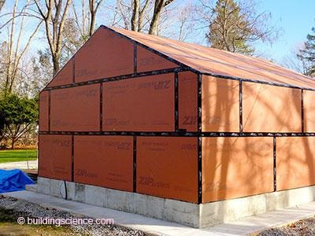
Photograph 1: Perfect Wall Meets Perfect Roof—OSB with an integral facing provides water control and facilitates taping. The taped OSB acts as the water control layer, the air control layer and the vapor control layer. Air and vapor control layer’s continuity between the wall and the roof is key. (source BSI-096)

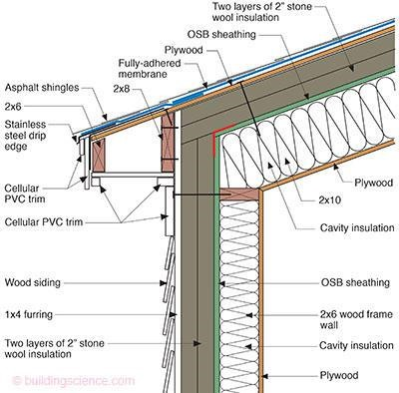
* Note: Diagram for rough idea of layer placement only – multiple layer changes include interior drywall vs plywood, 2x4 vs 2x6 walls, 2x12 vs 2x10 rafters, Polyiso vs stone wool insulation, 1” vs 2” insulation layers on wall, stucco vs wood siding, flat layed 2x4 furring strips added between exterior insulation and upper plywood and extending above eaves, and felt paper vs fully-adhered membrane beneath roof except in valleys.
Figure 2: Control Layers—Continuity of the air control layer, the vapor control layer and the thermal control layer at the roof-to-wall interface is provided by connecting the wall OSB sheathing to the roof OSB sheathing. (source BSI-096)

Walls
The walls are 2”x4”s on 16" centers, but 1”x6” or plywood 6” deep window bucks frame around the doors and windows. The bucks are installed with the extra 2 inches towards the exterior to match the thickness of 2" worth of exterior foam sheathing on the exterior.
ZIP sheathing is secured to the 2”x4”s for shear strength, and provides the air, water and vapor barrier. Flashing of the window and door openings at the sheathing layer for the water barrier could be challenging for the builder not used to it, but excellent articles are available which detail durable techniques. Two layers of 1" thick exterior foam board with each layer's seams offset from the layer below is ideal to account for possible shrinkage of the foam board over time, and increase the long-term protection of the structure. The top layer of polyiso is tape sealed. Furring strips of 1”x4” screwed through the foamboard into the 2”x4” framing secure the foamboard and provide a rainscreen while providing a good base for the stucco siding. Standard pine with epoxy coated screws work for the furring strips because they easily dry with the airflow allowed by the rainscreen.
With 2" thickness of external Polyiso (R-13.1) and R-13 in the stud cavities, the assembly is R-26 for the county, but true whole wall performance would be closer to R-23 with thermal bridging considered. True whole wall performance of the standard 2”x6” wall is closer to R-13 per the following link http://www.homeenergy.org/show/article/nav/walls/page/3/id/1517 . The standard 2”x6” wall also has a much less protected structure due to no rainscreen, and increased exposure to temperature extremes.
Roof
The roof is built as an insulated cathedral ceiling with a ridge beam and 2”x12” equivalent rafters which terminate just inside the wall sheathing. Rafter spaces will be filled with fiberglass or blown cellulose insulation and sealed by sheetrock on the interior. ZIP sheathing or similar will be installed over the rafters and on the ends of the rafters if required to join and seal with the wall sheathing. Two layers of 2” thick polyiso are installed with offset seams over the roof sheathing, the top layer is taped, and peel and stick membrane is utilized to tape the top polyiso layer to the outer polyiso layer of the wall. Furring strips for the roof are 2”x4”s layed on their sides which extend past the walls to provide the upper structural member to secure separately constructed eaves onto the structure. Specialty screws are required to go through the 1.5” thick furring +4” of polyiso and a minimum of 1.5” into the rafter tops. Plywood sheathing and tar paper are then placed over the furring strips, with metal roofing on top.
With 4" thickness of external Polyiso (R-27) and R-38 in the rafter cavities, the assembly is R-65 for the county with significantly less thermal bridging than exclusively internal insulation.

