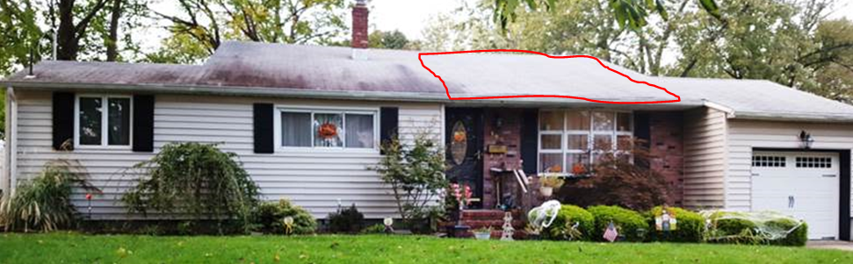

Living room vaulted ceiling is area circled in red in above picture

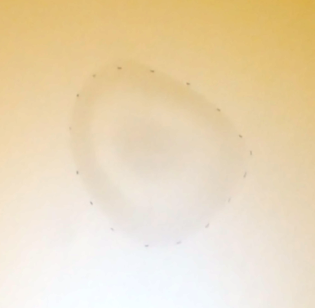

Picture of stain in living room vaulted ceiling (about size of a baseball)

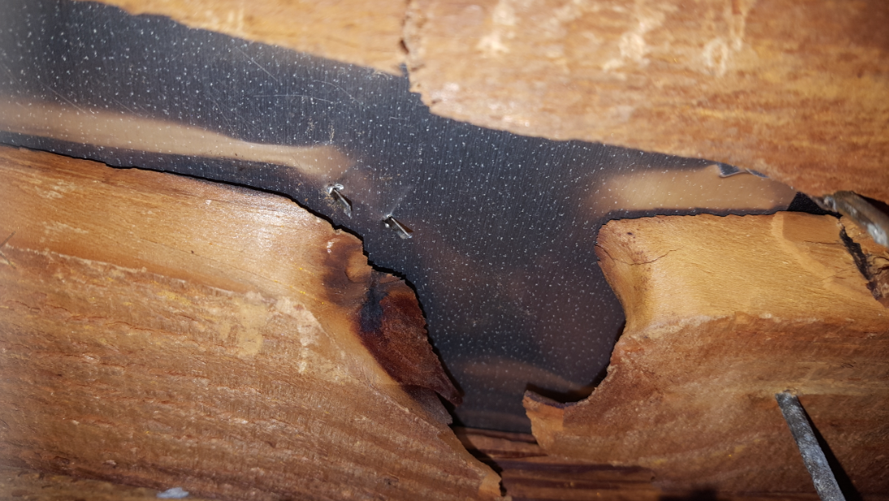

From the sheathing above living room vaulted ceiling that is visible from attic, noticed 3-4 spots where there looks to be sheet metal patches in the roof. No previous roof penetrations or trees in the area.