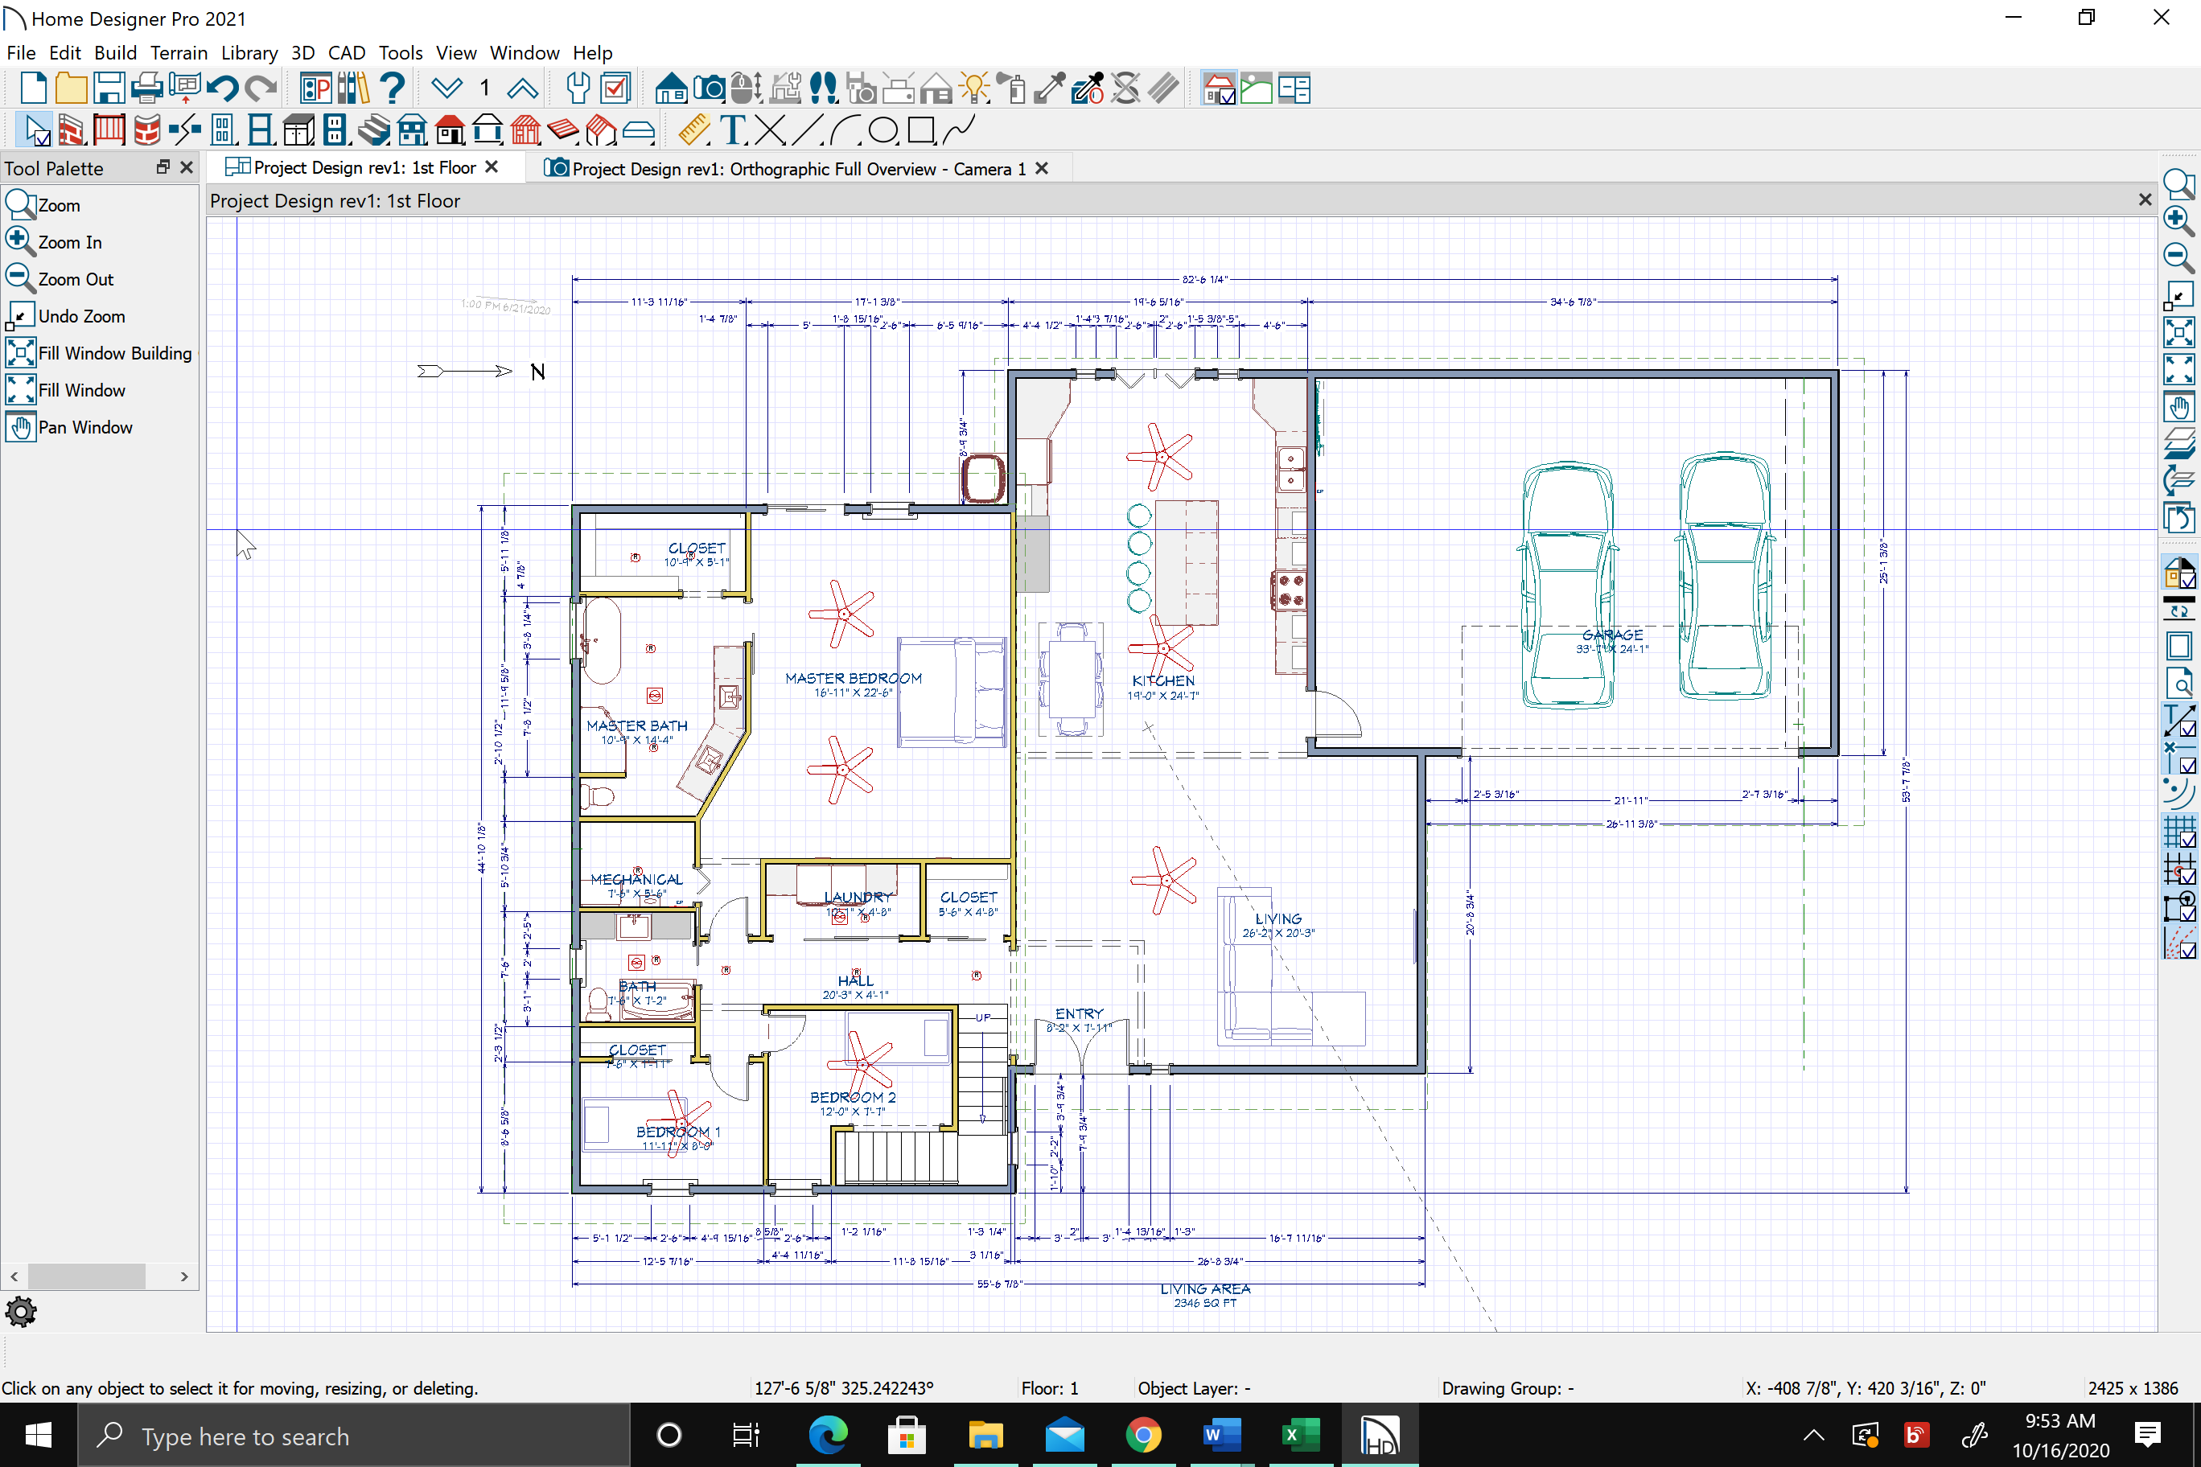

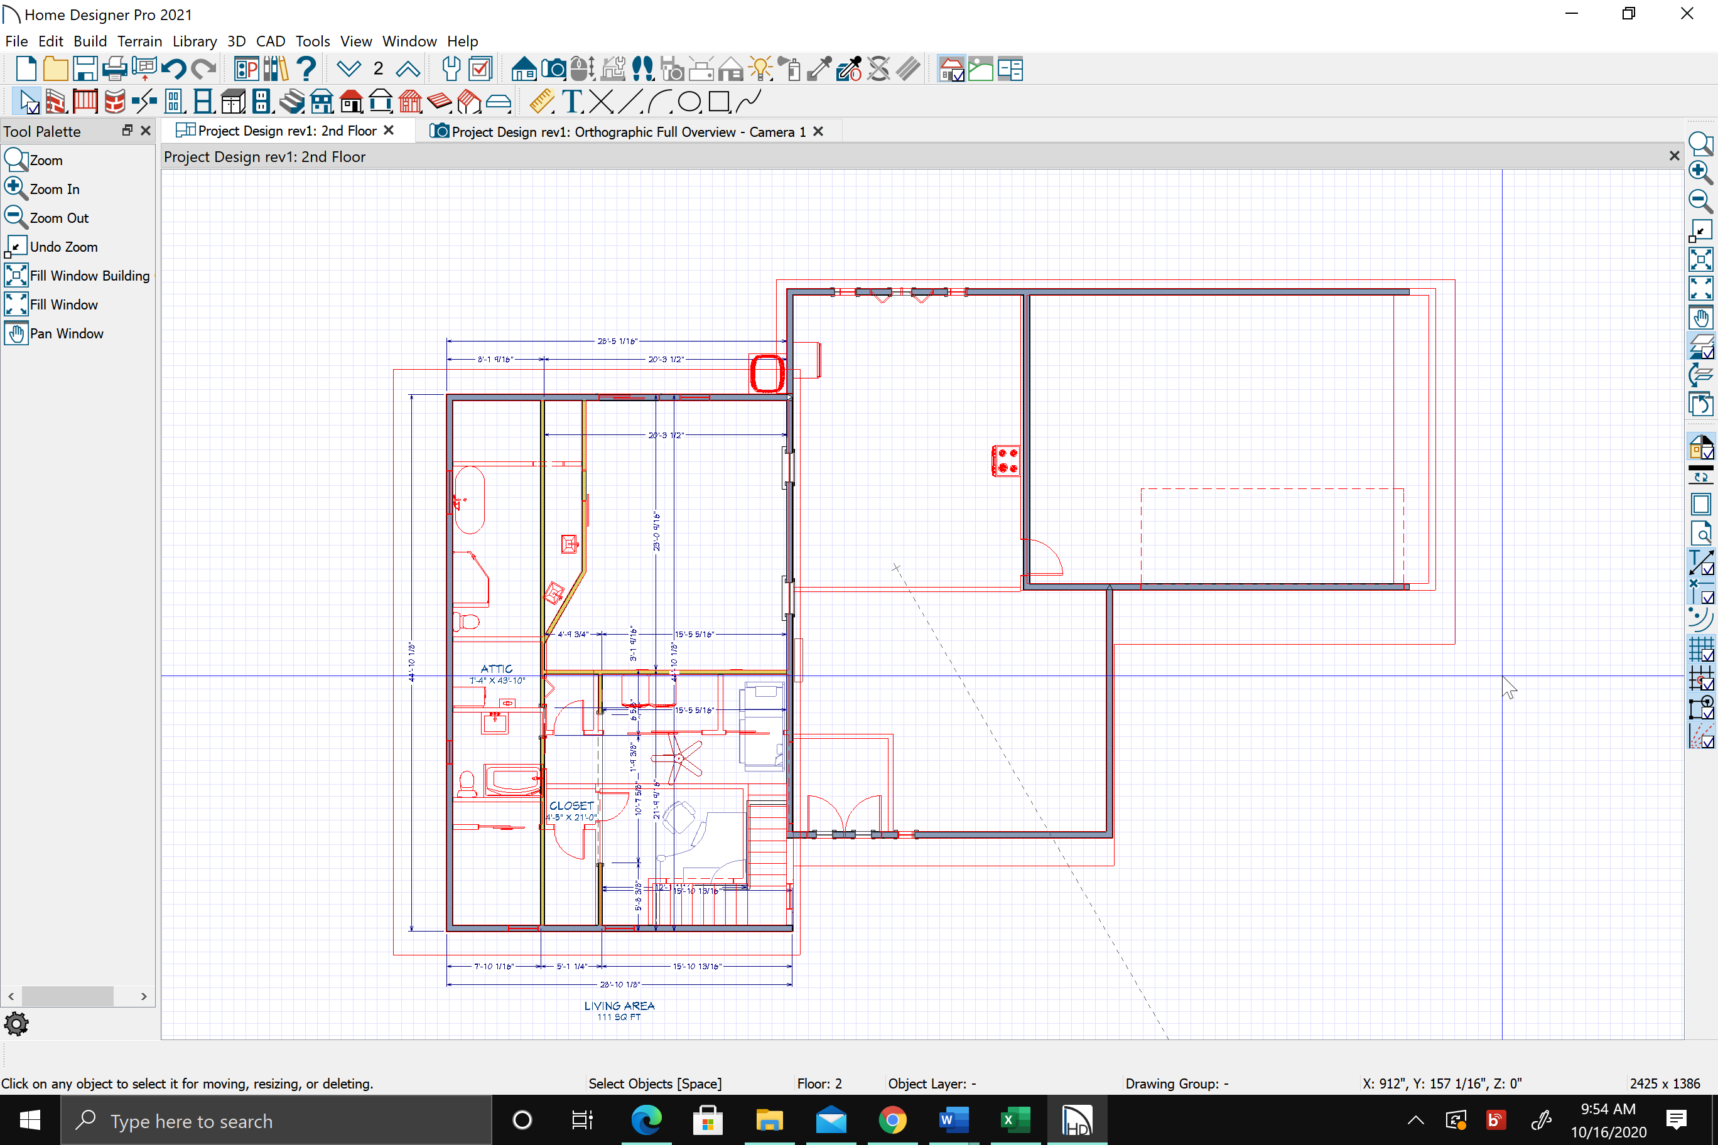

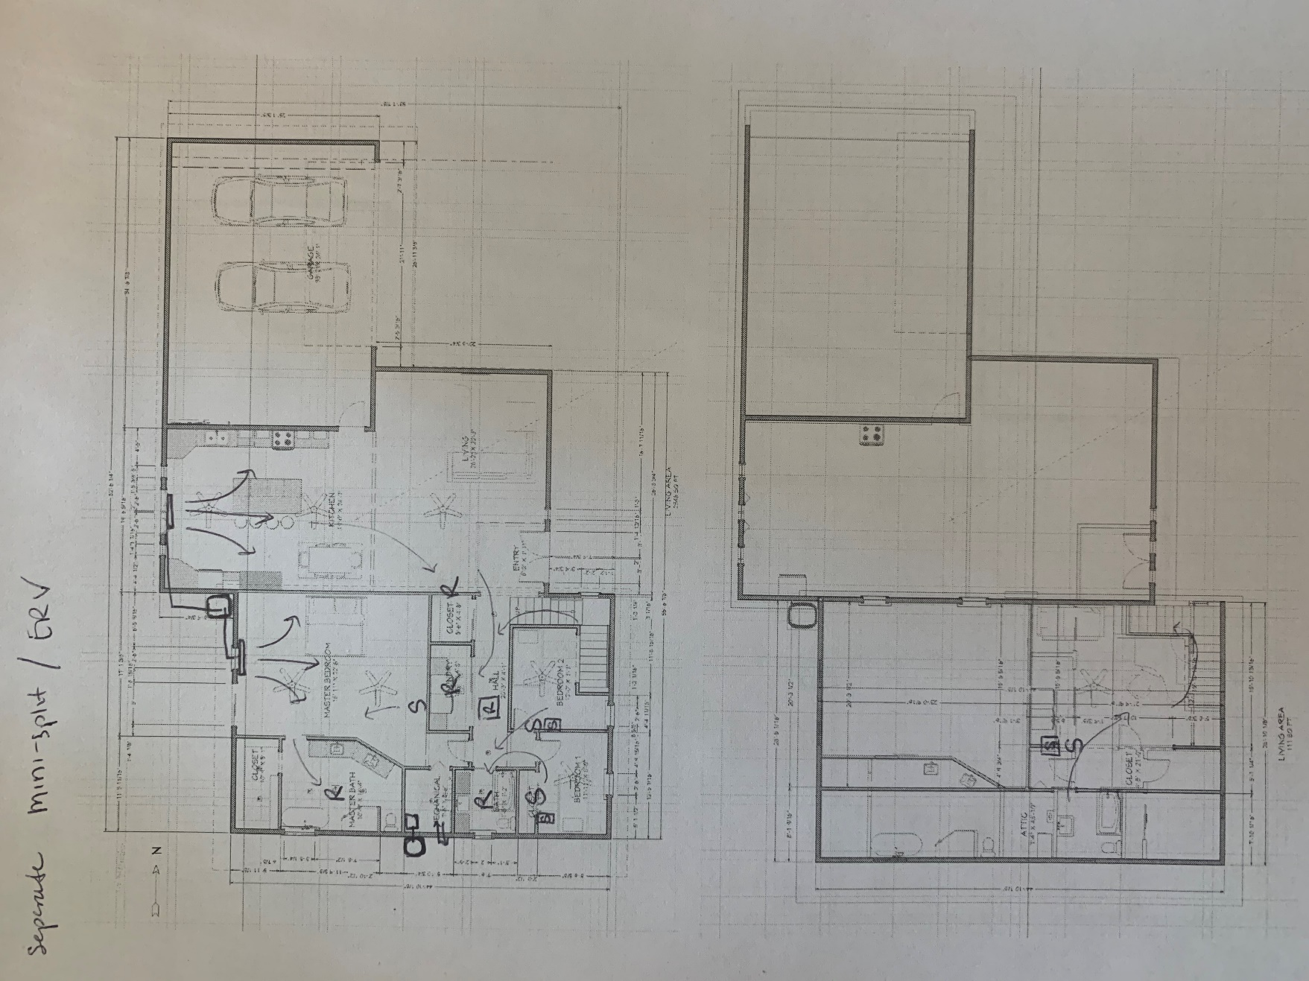

For ERV: S – supply, R – return

Boxed S or R – correspond to ducted unit

|  |  |  |
| --- | --- | --- |
| Space | cooling (btu/hr) | Heating (btu/hr) |
| Sleeping area | 14000 | 14000 |
| Master suite (inc sleeping area) | 18500 | 11000 |
| Living area | 6000 | 6200 |

