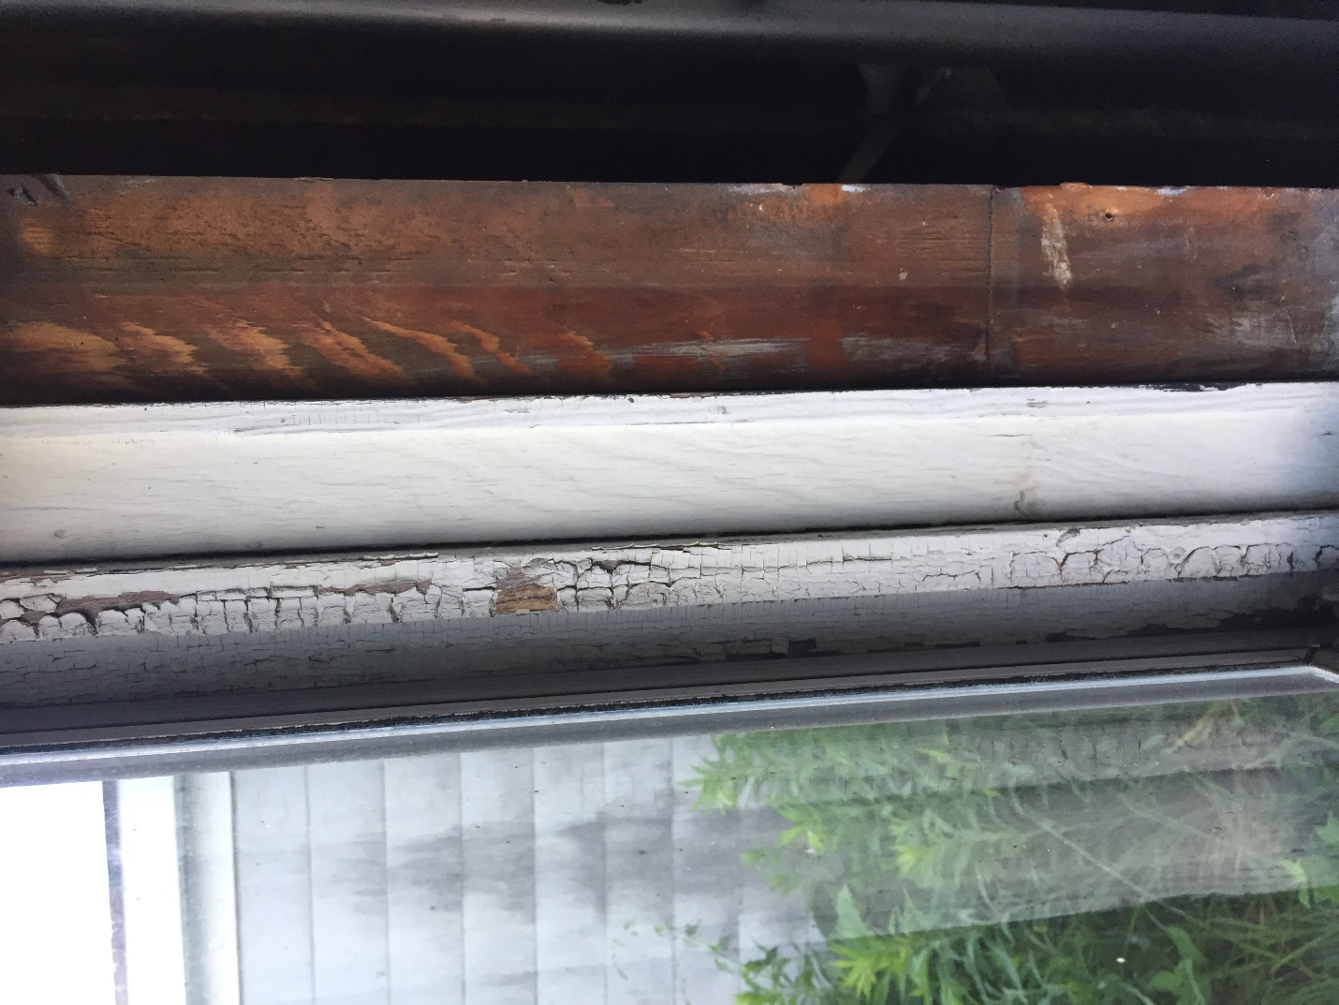

Jamb

Parting Bead

Jamb

Exterior Stop

Exterior Trim