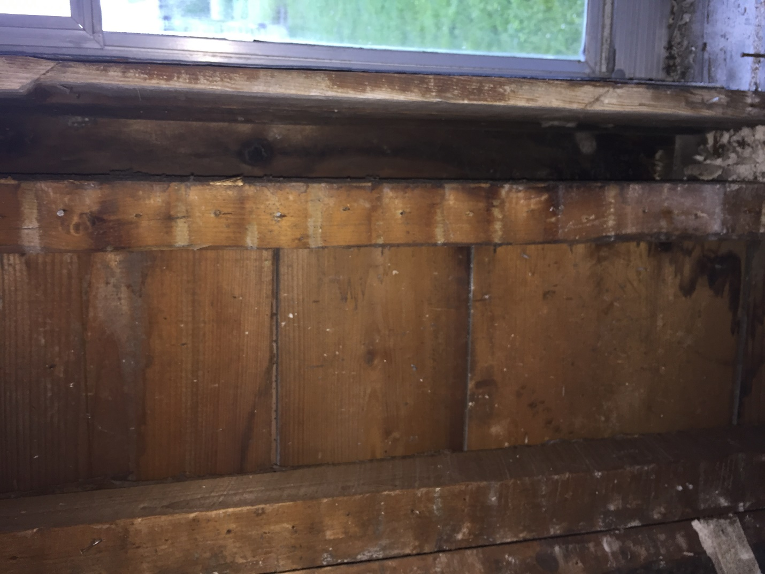

Sheathing

Rough Opening Stud

Exterior Window Trim

Sash Weight Pocket

Jamb