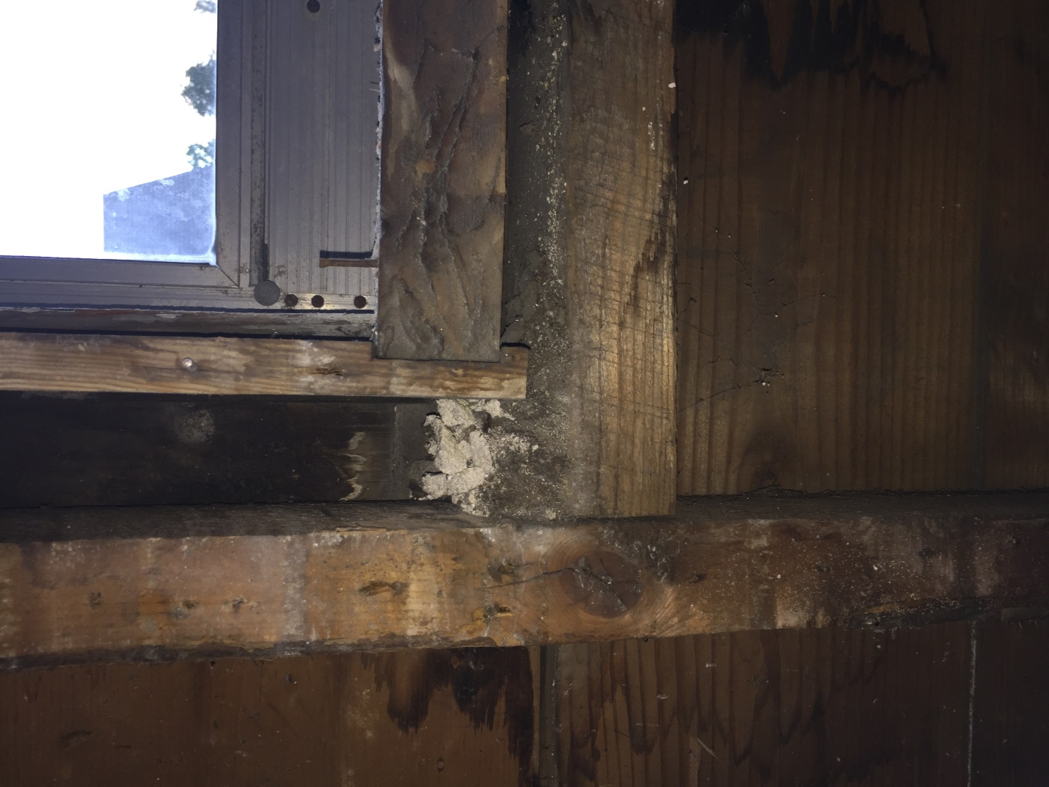

Jamb

Sill

Sash Weight Pocket