PRACTICAL, EASILY BUILT WALL SYSTEM… R-30 AND BEYOND

David Johnston & William Turner, PE

Abstract

The adoption of the 2015 International Energy Conservation Code has special ramifications for Climate Zones 6, 7, and 8. As shown in Table R402.1.2, IECC 2015, Zones 6,7, and 8 are effectively precluded from using “Cavity only insulation”. The minimum requirements of code compliance are written as “20+5” or “13+10” in the Wood Frame Wall R-Value column. The first number refers to cavity R value, and the second number refers to a continuous layer of insulation. Non insulation elements of the wall system, such as gypsum wallboard, plywood sheathing, or air films are not useable in the insulation calculations. The 2009 IECC did allow an option for “cavity only insulation”, written as “20” or “13+5”.

The obvious intent of the 2015 IECC is to manage conductive heat loss by minimizing thermal bypasses in the wall systems, thereby improving overall system performance. Continuous insulation methods that comply with the Code include standard stud construction with insulated exterior sheathing, standard stud construction with insulated interior sheathing, Zero Stud Construction such as Structural Insulated Panels or Insulated Concrete Forms, and finally Double Stud Construction. This paper will explore one such Double Stud Construction method, which the authors refer to as “Wrap and Strap” Construction.

The advantages to this method are ease of construction, rapid “dry-in” of the building, ready availability of materials, minimal use of foam insulation products, simple electrical wiring, simple drywall installation, and no special techniques required to install exterior cladding or interior trim. The one downside to the method, which is true of any method that applies the additional continuous insulation layer to the interior of the main exterior wall, is the loss of floor space. The “Wrap and Strap” method reduces overall interior dimensions by 7” in width and 7” in length. The loss in length is rarely a problem. The loss in width can be more noticeable, and effectively precludes this method in designs of 24’ widths and less. Building widths of 26’ or more work perfectly well.

This is not an entirely new method. The authors constructed a house in 1984 using a more primitive form of “Wrap and Strap”, which was featured in the August/September 1986 issue #34 of Fine Homebuilding, “A Superinsulated Saltbox”. It is still in operation, and performing well for the owners, who are heating it with a 12,000btu Fujitsu mini split.

Method of Construction

Once the floor is constructed, whether frostwall and slab or a wood framed floor over a basement or crawlspace, 2x6 studs are laid out 24” on center, with a single bottom plate and a double top plate. The wall is sheathed while down, appropriate water control layers applied, and then stood in place on a bead of Tremco™ Acoustical Sealant or equivalent.
This process continues until all the walls are stood, ready for a second floor or roof
construction. If a second floor is planned, the floor framing is set back 2” from the exterior of the stud faces, and 2” of rigid board is placed in the resulting cavity. See illustration.

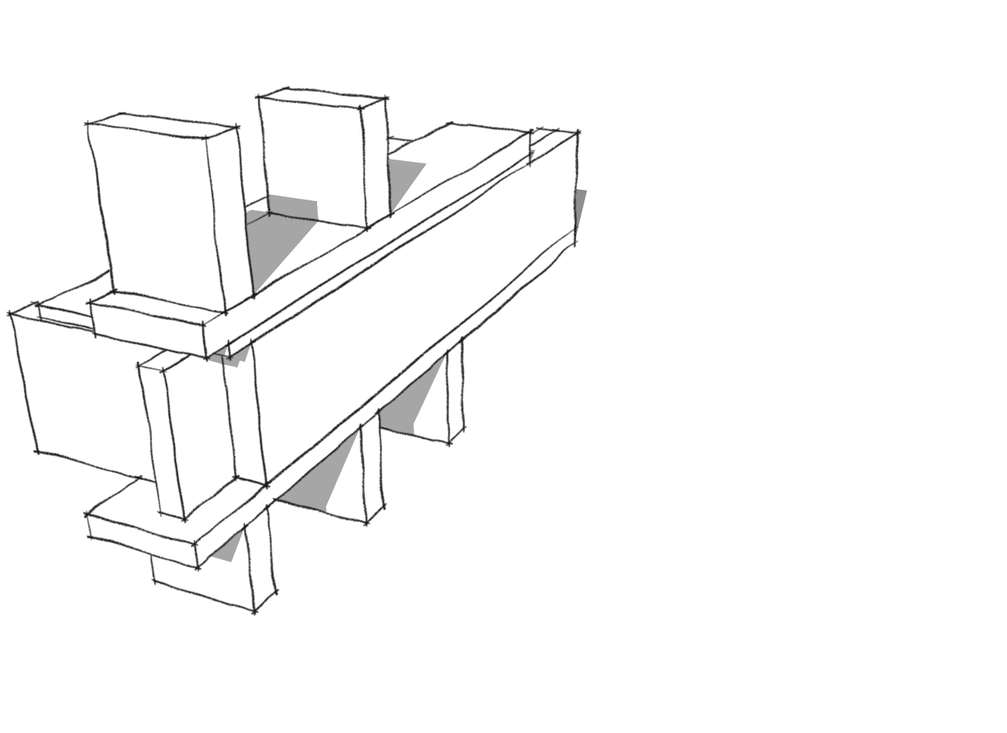
2” XPS/EPS

The authors prefer that window and door headers consist of insulated hollow plywood boxes, sized to fill the header cavity from window to the underside of the top plate.

With the roof completed and the structure protected from rain and snow, windows and doors are installed according to manufacturers’ specifications, paying close attention to flashing and air sealing. At this point, the first installment of insulation takes place, consisting of dense packed cellulose in the 2x6 cavity. No wiring or plumbing has taken place as yet, and no interior partitions are erected other than those required structurally. In fact, no interior partition pick-ups are required at all. The authors caution here that the Building Inspector or Code Official should be made aware of the necessity for one additional inspection prior to this first insulation installment. From this point onward, all interior work is undertaken in a weathertight shell, making scheduling simpler and less prone to disruption.

Once the first insulation application is complete and inspected, a vapor diffusion retarder can be applied over the interior surface of the insulated wall. With no wiring or plumbing or partitions in the way, this is easily accomplished. It can be applied with regular staples, since it is out of the wind and protected inside the building. This process constitutes the “Wrap” of “Wrap and Strap”. Joints in the membrane are made with Tremco™ Acoustical Sealant. Windows and doors are extended towards the interior with premade 2x4 extension jambs. Window jambs are usually aligned with the window framing, while the door jambs are stepped back from the door frame 1 ½” on each side and at the top. The next step is the installation of the horizontal purlins, which consist of 2x4 KD lumber in appropriate lengths. To prevent the lowermost horizontal purlin from aligning with the bottom plate of the 2x6 stud wall, a foam “purlin” is installed on the floor, consisting of a strip of 2” XPS/EPS ripped to a width of 3 ½”. The first 2x4KD purlin is set on top of this strip, and screwed to the vertical 2x6 studs. See illustration.

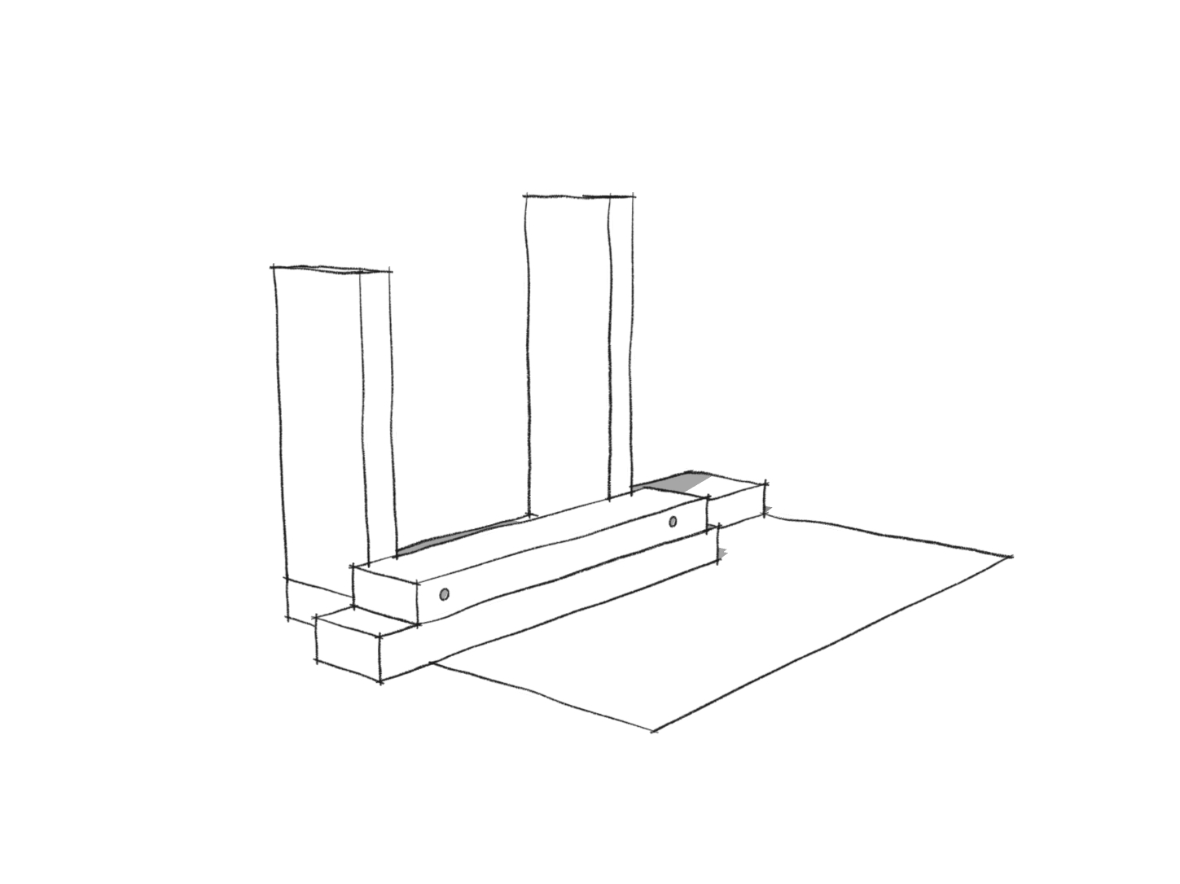
2x4 Purlin #1

XPS/EPS “purlin”

To obviate the need for excessively long screws, the 2x4 purlins are drilled with a countersink to a depth of 2”, which allows the use of 4” GRK type screws. The authors found that a Kreg™ step drill bit with the collar set to the correct depth, greatly facilitates this process. See photograph.

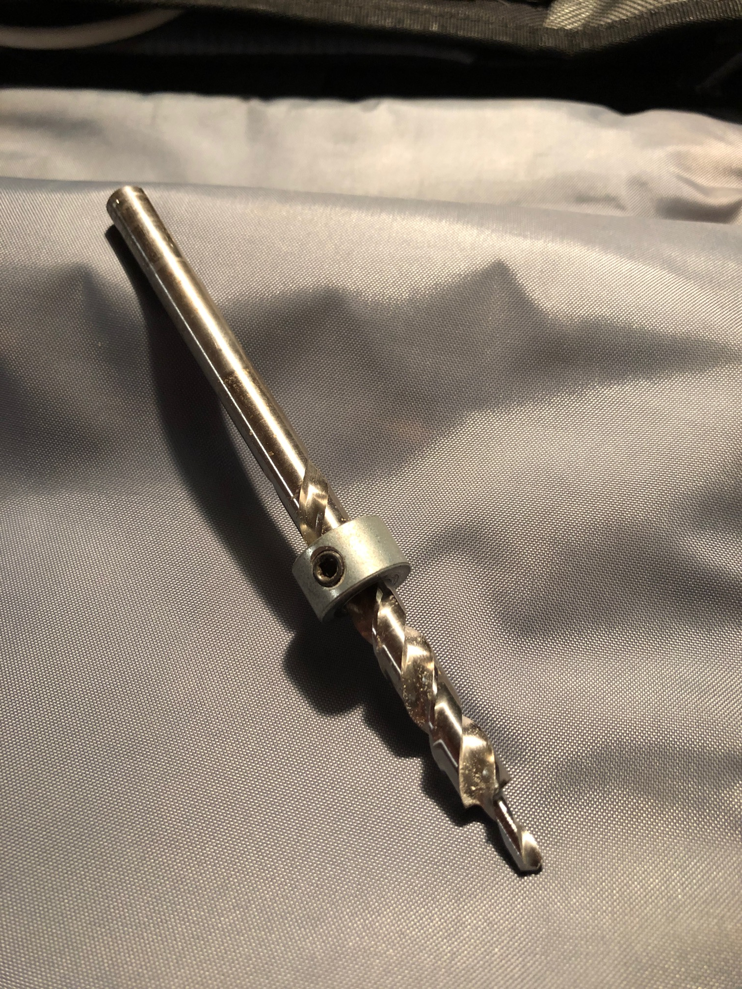

A spacer stick, sized to guarantee a snug friction fit for 24” batt insulation, is now used to install the next purlin going up the wall from bottom to top. Chalking a line is far less accurate than the spacer stick method, as the authors discovered. The horizontal purlins continue up the wall, with the final purlin installed below the level of the top plates of the 2x6 wall, to prevent alignment and to provide a thermal break.

Once the horizontal purlins are completed, which constitutes the “Strap” portion of the system, interior partitions are easily installed and fastened to the purlins. From here on, with some exceptions, standard practices are utilized to complete the project. The exceptions consist of the need for short vertical 2x4 pieces (the same length as the spacer stick above) installed as the electrician directs, though not aligned to the 2x6 studs in the exterior wall, to accept switch and outlet boxes on the exterior wall. Also, vertical 4x2 pieces will need to be installed as the kitchen supplier or cabinetmaker so directs, to facilitate hanging cabinets.

See photographs.

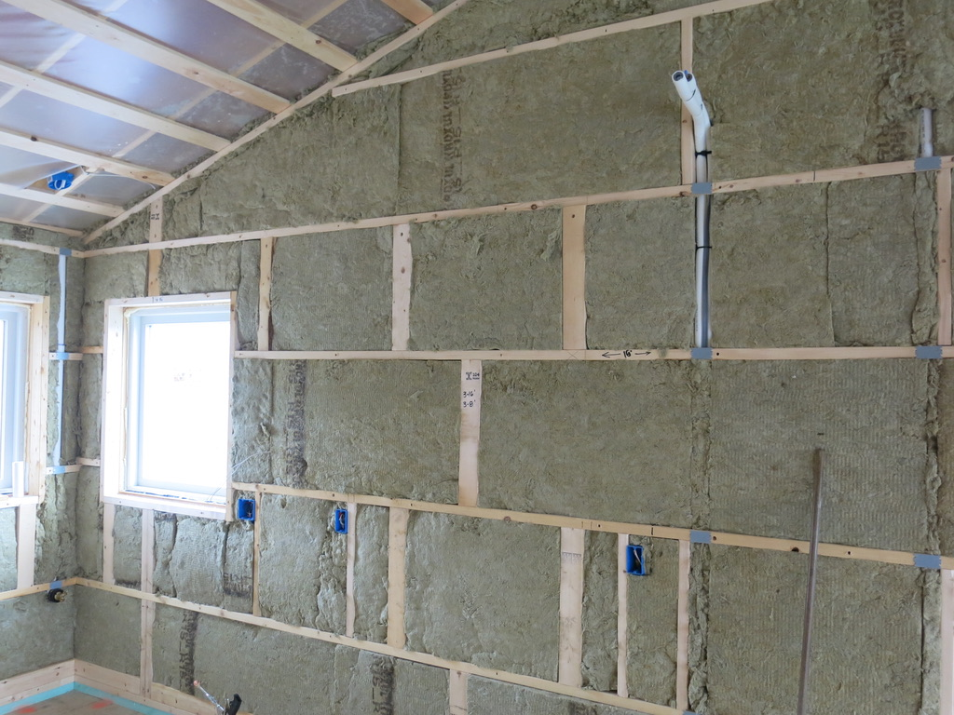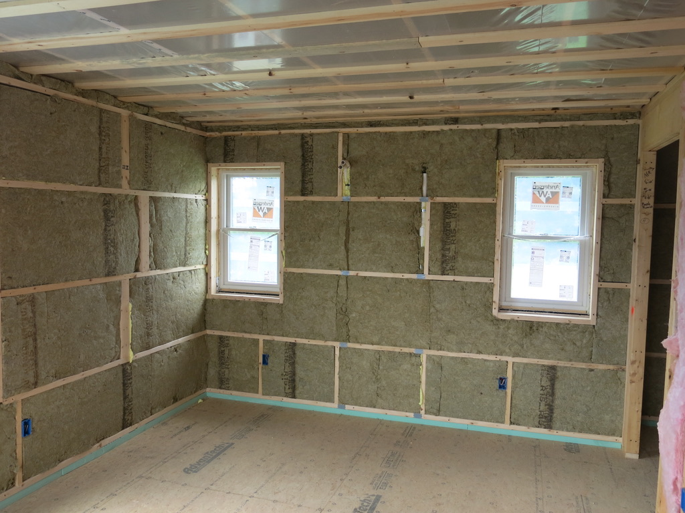

Another exception to standard practices is the method of hanging drywall on the purlins of the exterior wall. The sheets will need to be installed vertically, not horizontally as is typically done. However, this poses no problem to the installer or taper, since nailing is readily apparent and no butt joints will need to be dealt with. See photograph.

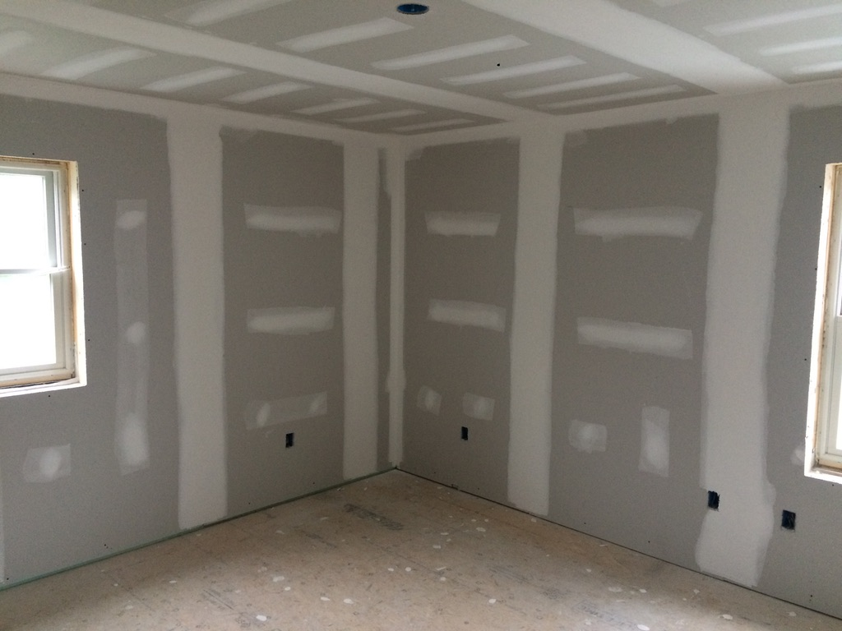

Lastly, the finish carpenter must be made aware that installing baseboard trim requires
trim screws, installed more or less in the mid line of the baseboard trim.
The installation of the purlins is the most significant departure from normal stud wall construction, which is no longer allowed under 2015 IECC. In the house featured in the presentation, which measured 30’ x 56’, with 8’ ceilings, two carpenters required no more than five hours, or ten person hours, to install 860 lineal feet of 2x4 purlins (172LF perimeter times 5 horizontal runs) which, at a rate of $45.00/hour, amounted to $450.00. The cost of the 2x4 material amounted to $425.00. Supply and installation of 3 ½” x 24” Roxul™ mineral wool insulation amounted to approximately $1.50 per square foot, or $1650.00.

The question arises as to the amount of wall area that is represented by the intersections between the vertical 2x6 studs and the horizontal 2x4 purlins. Ignoring the doors and windows, the calculation is as follows:

Building perimeter = 172 lineal feet
Total number of vertical studs = 100
Number of horizontal runs = 5
Total number of intersections = 500
Individual intersection area = .016 square feet
Total intersection area = 500 x .016 = 8 square feet
Total wall area = 172 x 8 = 1376 square feet
Percentage of wall area/intersection = 8/1376 x 100 = 0.58%

About one half of one percent of the total wall area consists of an intersection area, having an R-value reduced to R-9. The overwhelming portion of the wall system achieves an R value of over 34.

Conclusions

The authors have been involved in high performance energy efficient design and construction since 1982, utilizing Double Stud Wall construction, Single Stud construction with exterior insulated sheathing, Single Stud construction with interior polyisocyanurate sheathing, and the “Wrap and Strap” method outlined above. They know of no other system that matches the “Wrap and Strap” for ease of design and construction, use of commonly available materials, and logistical simplicity. The additional cost of the system amounts to approximately 1% of the typical cost of a well built home in the New England area.

