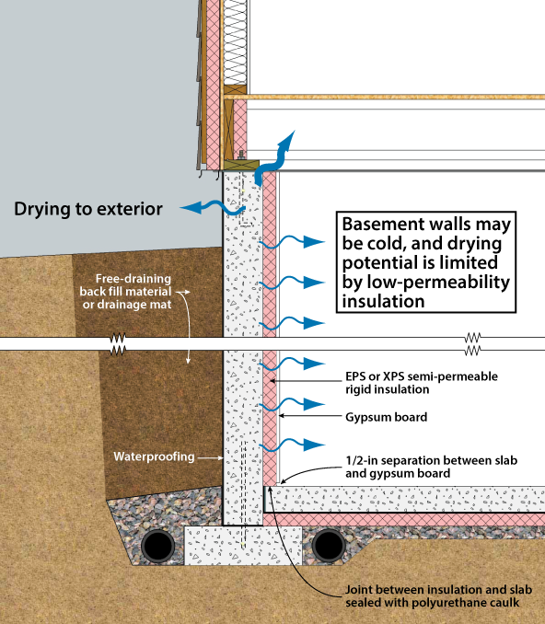

From Oak Ridge Nat. Lab; Foundation Design Handbook; Document # ORNL/TM -2014/70

